UNIVERSITY OF MINNESOTA

Duluth Campus Department of Studies in Justice, Culture, and Social Change 228 Cina Hall
College of Arts, Humanities, and Social Sciences 1123 University Drive
Duluth, Minnesota 55812-3306
E-mail: troufs@d.umn.edu
ZOOM: https://umn.zoom.us/my/troufs
20 October 2024


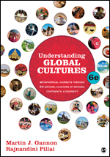

f2024 Week 9 Module

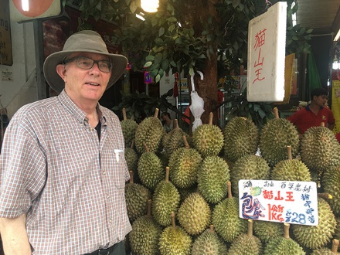

Tim Roufs, Singapore Market, 2017

Anthropology of Europe Week 9

What’s Happening Week 9?

        - READ AND WATCH
          - READ TEXT . . .
          - VIEW SLIDES
          - WATCH VIDEO
            - Watch Video Clips
          - IN-THE-NEWS
        - MIDTERM EXAM
        - DISCUSSION
        - PROJECT
        - OTHER
            - EXTRA CREDIT
            - FOR FUN TRIVIA (optional)
            - LIVE CHAT (optional)
Tuesday 7:00-8:00 p.m.
        - QUESTIONS / COMMENTS / SUGGESTIONS
        - WRAP-UP
[click ↑ here]

What’s Happening Week 9?

From Ireland we bid slán and venture off to India—a country that has been intimately connected with England and the United Kingdom for hundreds of years, essentially beginning with the establishment in A.D. 1600 of the East Indian Company under the Tutor Queen Elizabeth I (daughter of King Henry VIII and Anne Boleyn).

India did not gain its Independence from England until 1947 (171 years after the American Colonies declared its independence from England).) British Indians today are the single largest visible minority in the United Kingdom, numbering about a million and a half people (2011 Census). And they contribute much to modern-day life in the United Kingdom.

From Ireland we’re going to the city of Varanasi in India, located along the banks of the sacred Ganges River, where several families share with us their very last moments with their dying relatives. The Irish, and especially the Irish Catholics, are known to deal with death in a matter-of-fact manner, and get on with living. So too are Hindu individuals from India. This week some share with us the last hours of their beloved family members. It is a way of life and death not familiar to most of us.

In anthropology these “Life Cycle” events including birth and death have always been of great interest, including how living folks interact with their departed ancestors, and how the transition from this life to the next (for those who believe in a next life) takes place.

This week we visit with families in India who are saying goodbye to their relatives at a sacred location along the Ganges River, in the city of Varanasi. To die in the city of Varanasi, on the banks of the sacred Ganges, one of the most cherished of Hindu religious aspirations in India.

And we’ll also have a look at this week’s news from India.

Read and Watch Week 9

READ THE TEXTBOOK FOR WEEK 9
Textbook Information
Readings for the Semester

REM: Links on screenshots are not “hot” (active)
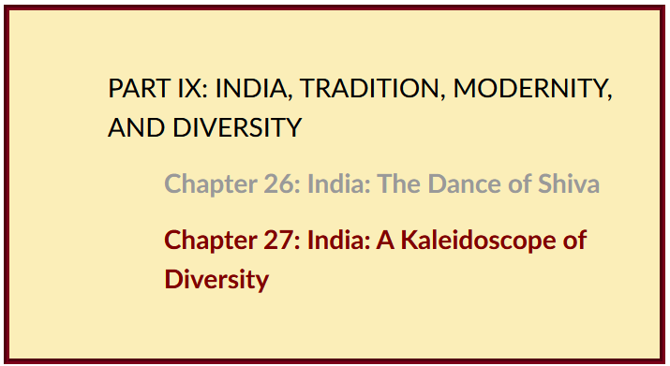

VIEW THE SLIDES FOR WEEK 9
Class Slides for the Semester

Italy: Introduction
slides: (.pptx)
[click ↑ here]

Italy:
slides: (Your choice of one other supporting topic)

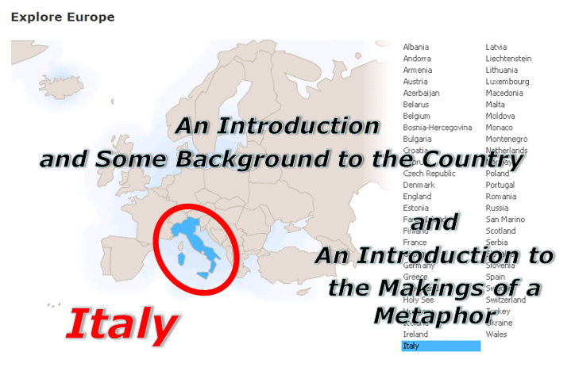

WATCH THE VIDEO EXPLORATIONS FOR WEEK 9
Real People . . . Real Places . . .
Videos for the Semester

This week we have a look at the internationally acclaimed film . . .

Ganges: River to Heaven
[India]
(52 min., 2003)

On-line Access
[click ↑ here]

course viewing guide



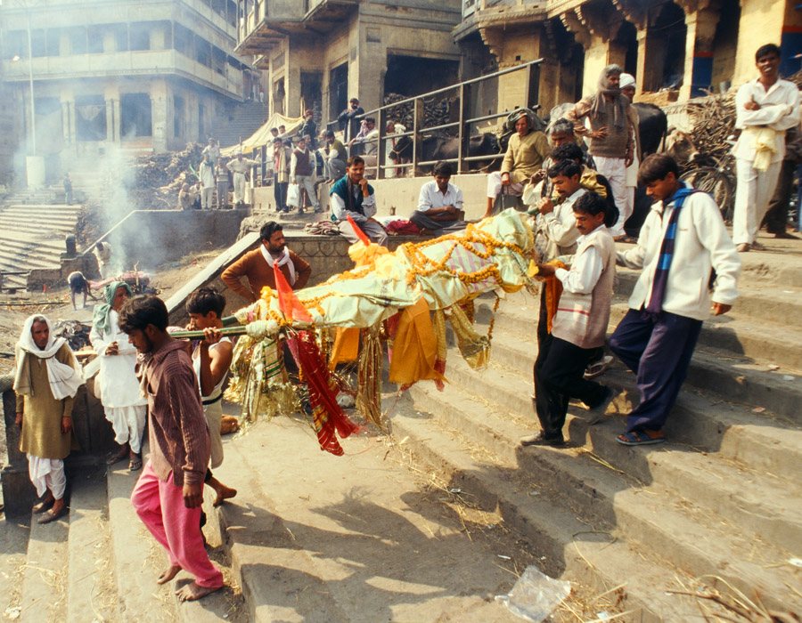

"This documentary explores one of the most cherished of Hindu religious aspirations: to die in the city of Varanasi, on the banks of the sacred Ganges, in the faith that dying here assures liberation from the cycle of earthly life."

"In the city of Kashi [in the location of modern-day Varanasi] the power of Ganga, the Hindu mother-goddess of the Ganges River, is strongest. Each dawn she calls her children to the ghats, the steps leading down to the water's edge. The young and strong purify themselves in Ganga's polluted waves. The old and the infirm, too weak for rituals, wait for death. In time, Ganga carries their souls, released from the bondage of reincarnation, to heaven. Their bodies, as ash afloat her crests or flesh submerged in her depths, return to the river. Once privy only to the dead and those who mourned them, the final journey of the devout Hindu is the subject of Gayle Ferraro's latest film, 'GANGES: River to Heaven.'”

"Filmed in a hospice for the dying and on the ghats of Kashi, India's religious heart, 'GANGES' follows four families' struggle to grant a loved one's final wish: to go to heaven. In their common quest the families become a fraction of the hordes of Hindus drawn to Kashi's holy promise of freedom from reincarnation. As the clans prepare for death, the citizens of Kashi manage life—praying for health, dumping industrial waste, begging for pocket change, bathing their children, selling to tourists, monitoring fecal chloroform levels, cremating their mothers-—all along the banks of the Ganges River. The families' preparations go virtually unnoticed on the river, where death is a daily part of life."

"GANGES: River to Heaven investigates the inextricable bond between a river and its people with unparalleled intimacy and depth. From the ghat workers gathering wood for the next cremation, to the chemists gathering water samples for contamination testing, each perspective sheds new light on India's evolving society and its unchanging veneration of the Ganges. The documentary of a sacred river, polluted from years of overuse, 'GANGES' wonders if the natural force strong enough to sculpt the peaks of the Himalayas and the beliefs of a nation will survive the adoration of generations to come."

WATCH THE VIDEO CLIPS FOR WEEK 9

Watch Video Clip
Class Slides for the Semester

IN-THE-NEWS WEEK 9
Media Bias Chart
Fake News

Sign Up in your Course Google Drive Folder:
f2024 <https://docs.google.com/document/d/1IlkUMRHy7ZPeIbxYelRuFGw4Vc5ZwXwv1e-qKEgDDvk/edit?usp=sharing>
[click ↑ here]

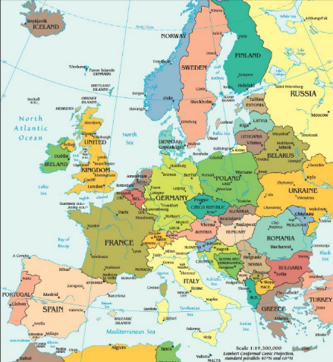

India – tba

FINAL EXAM . . .
General Midterm Exam Information

DISCUSSION FOR WEEK 9
Online Discussions Information, Rubric, and Sample Posts

Discussion: What Role Should the Pope Play in Europe?


Pope Francis

PROJECT INFORMATION . . .
Basic Information
Main Due Dates

If you haven’t already done so, schedule some serious time blocks to work on your Project. And think about is how you might present your findings to others.

OTHER . . .
Main Due Dates

f2024 Module Week 9

Check out the Life Cycle: Death information

(optional) EXTRA CREDIT . . .
Basic Extra Credit Information

If you didn’t do quite as well as you might have liked on the Midterm Exam, or if you did better than you even hoped on the Midterm exam but want to “bank” some insurance points for your final course grade, think about doing one (or even two—one of each) of the optional extra credit papers.

There are two Extra Credit options: (A) a case study, and/or (B) a review of a lecture or event, or an approved film (other than one of the films we see in class). For the review option you may also compare two or more films. (Remember from Week 1, one of the main features of anthropology is that it is comparative?)

Details on the extra credit are on-line at
<http://www.d.umn.edu/cla/faculty/troufs/anth3635/extra_credit/ceextracredit.html#title>

Be sure to check the details of the activities and assignments each week in your folder.

FOR FUN TRIVIA (optional)
Food Trivia HomePage

“What is the smallest country [sovereign entity] recognized by international law?”

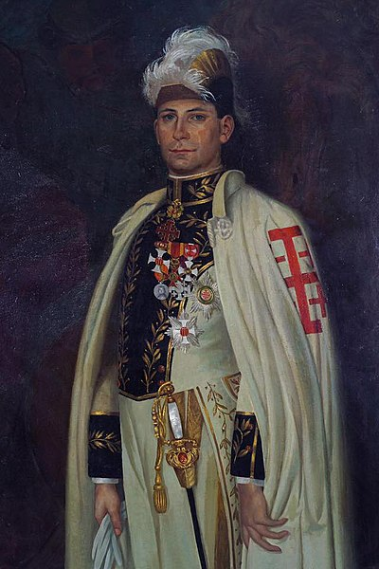

Wikimedia
Knight of the Order of the Holy Sepulcher of the Holy See, ca., 1900
Immagine scannerizzata da "Ordini cavallereschi e cavalieri", di Arnone, C, 1954

(Answer)

LIVE CHAT OPEN FORUM / OFFICE HOURS . . . (optional)
Tuesday 7:00-8:00 p.m. (CDT) On ZOOM
Contact Information
“ZOOM”
[click ↑ here]
or
e-mail anytime: mailto:troufs@d.umn.edu
[click ↑ here]

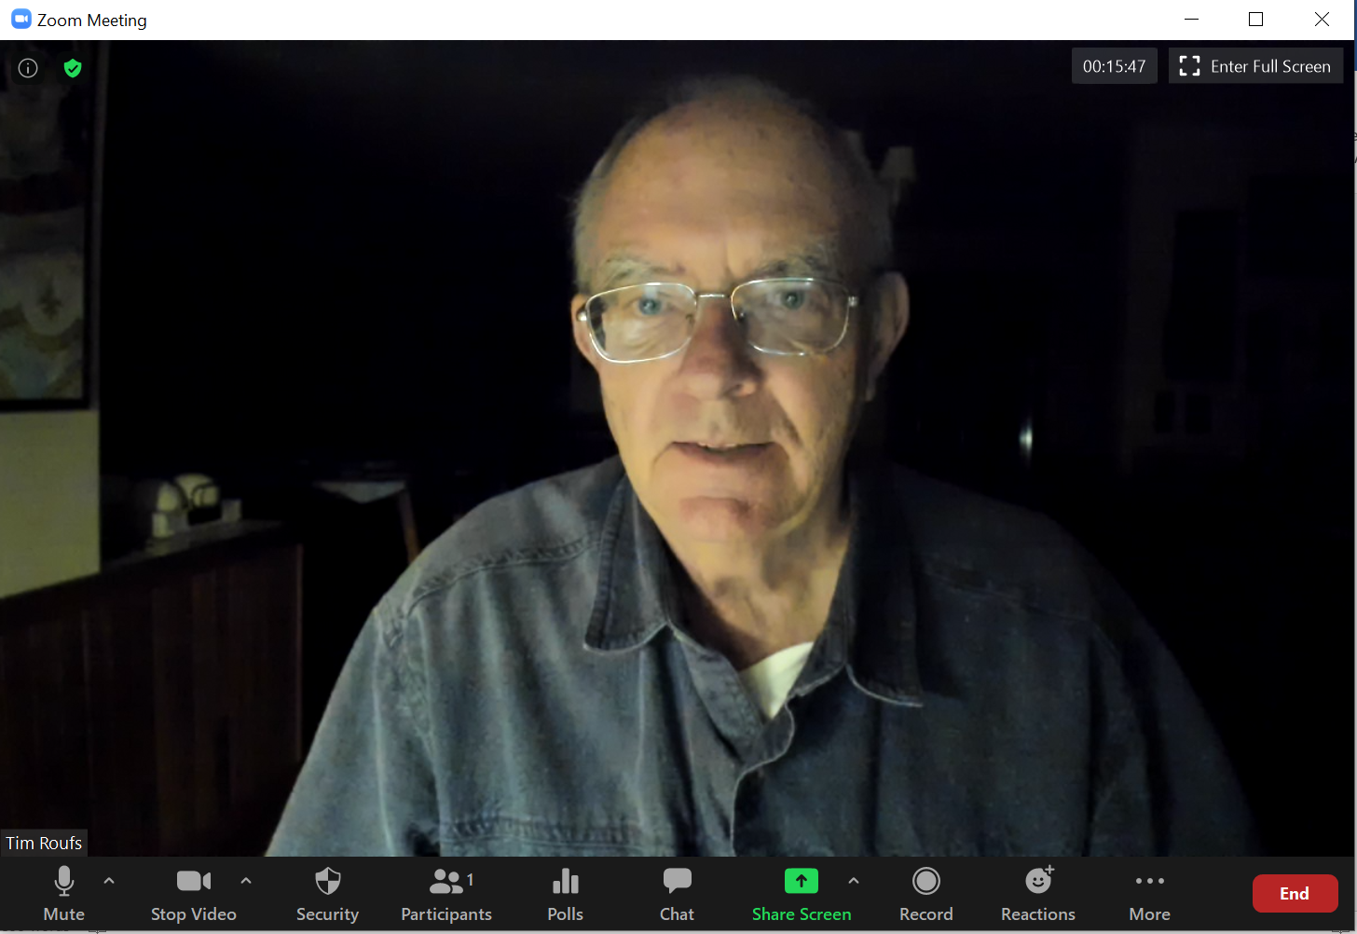

Live Chat is optional.

QUESTIONS? / COMMENTS / SUGGESTIONS . . .

If you have any questions or comments right now, please do not hesitate to post them on the “Discussions”, or e-mail troufs@d.umn.edu, or ZOOM https://umn.zoom.us/my/troufs. (E-mail is fastest, and most generally best as quite often URLs need be sent.)

Best Wishes,

Tim Roufs

<http://www.d.umn.edu/~troufs/>
<https://umn.zoom.us/my/troufs>
<other contact information>

